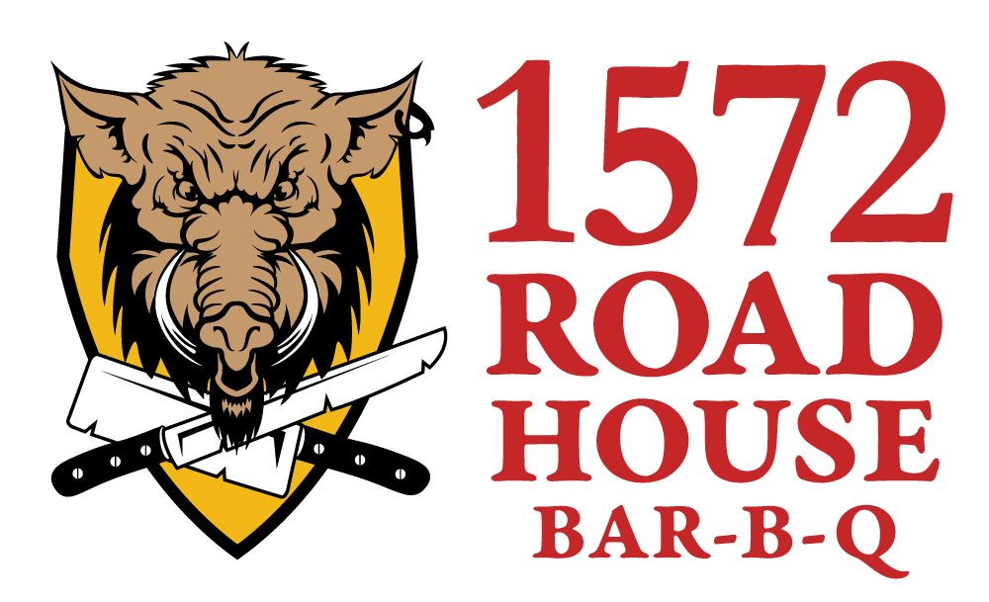
7/1/16
FOR IMMEDIATE RELEASE

Contact: Cheryl Bucholtz, Marketing | 513-897-7000, Ext. 242 | cheryl@brimstoneandfirellc.com

New barbecue eatery is now open on the grounds of the Ohio Renaissance Festival
Harveysburg, Ohio (July 1, 2016) – The 1572 Roadhouse Bar-B-Q located on the grounds of the Ohio Renaissance Festival has officially opened its doors. The eatery features rubbed and smoked meats with three homegrown sauces available, rotating microbrews and local favorites on tap, as well as a massive deck to enjoy some “great ‘Q’ and frosty brew.”
The 1572 Roadhouse Bar-B-Q has two Pitmasters from the Dayton area behind the saucy recipes. Chris Cavender and Mike Tenore have put their own spin on all of the menu selections. Choose from sandwiches, chicken, ribs, side dishes, snacks, and desserts all prepared to perfection. Enjoy selections a la carte or make a platter with two sides.
1572 Roadhouse Bar-B-Q Hours of Operation
Thursday | 4:30pm – 9pm
Friday | 4:30pm – 9pm
Saturday | 12pm – 9pm
Sunday | 12pm – 8pm
The 1572 Roadhouse Bar-B-Q will also operate during the Ohio Renaissance Festival season from September 3 thru October 23. For hours of operation, please check the calendar online at http://www.1572roadhousebarbq.com/.
Bike Nights
Every Thursday night at the 1572 Roadhouse Bar-B-Q is Bike Night presented by Buckminn’s D and D Harley-Davidson of Xenia, Ohio and sponsored by Budweiser. Riders can ride through the castle gates and put their bike on display inside the 16th Century village. Bike Nights kick-off at 6pm and will run every Thursday until the weather is too chilly to enjoy the outdoor setting.
Location
On the grounds of the Ohio Renaissance Festival (Renaissance Park)
10542 East State Route 73
Waynesville, OH 45068

Connect With Us

Online: www.1572roadhousebarbq.com

Facebook: www.facebook.com/1572RoadhouseBBQ

Phone: 513-897-7000

E-mail: info@1572roadhousebarbq.com

The 1572 Roadhouse Bar-B-Q is owned and operated by Brimstone & Fire, LLC, producers of the Ohio Renaissance Festival and Celtic Fest Ohio.

###

